**CAR PRICE PREDICTION ANALYSIS**

**INTRODUCTION**

The Car Price Prediction Analysis aims to leverage data analytics techniques to analyze car listings and predict car prices based on various attributes. With the rapid growth of the automobile industry, pricing a car accurately is crucial for both buyers and sellers. Various factors such as brand, model, year of manufacture, fuel type, transmission, and mileage significantly influence a car's market value. By using data-driven techniques, we can uncover hidden patterns and trends that help stakeholders make informed decisions.

This project involves cleaning and processing raw data, applying analytical techniques, and using machine learning models to generate price predictions. The insights derived from this analysis can assist individuals and businesses in optimizing their pricing strategies, evaluating market trends, and making data-driven purchasing decisions.

**DATASET OVERVIEW**

* **Dataset Description:** The dataset contains car listings with attributes such as brand, model, year, mileage, engine type, fuel type, and price.
* **Key Attributes:**
  + *Make & Model:* Brand and model of the car.
  + *Year:* Manufacturing year.
  + *Mileage:* Distance travelled.
  + *Fuel Type:* Petrol, Diesel, Electric, etc.
  + *Transmission:* Automatic or Manual.
  + *Price:* Selling price of the car (Target Variable).

**DATA CLEANING PROCESS**

* Removed missing and duplicate entries.
* Converted categorical variables (e.g., fuel type, transmission) into numerical representations.
* Normalized continuous variables (e.g., mileage, price) for better predictions.

**DAX FUNCTIONS USED**

* **CALCULATE:** Modifies filter contexts to derive insights.
* **SUM, AVERAGE:** Computes total and average price calculations.
* **IF:** Applied for conditional transformations.
* **COUNTROWS:** Counts the number of rows in a table.
* **TOPN:** Returns the top N rows from a table based on a specified expression.

**DASHBOARD OVERVIEW**

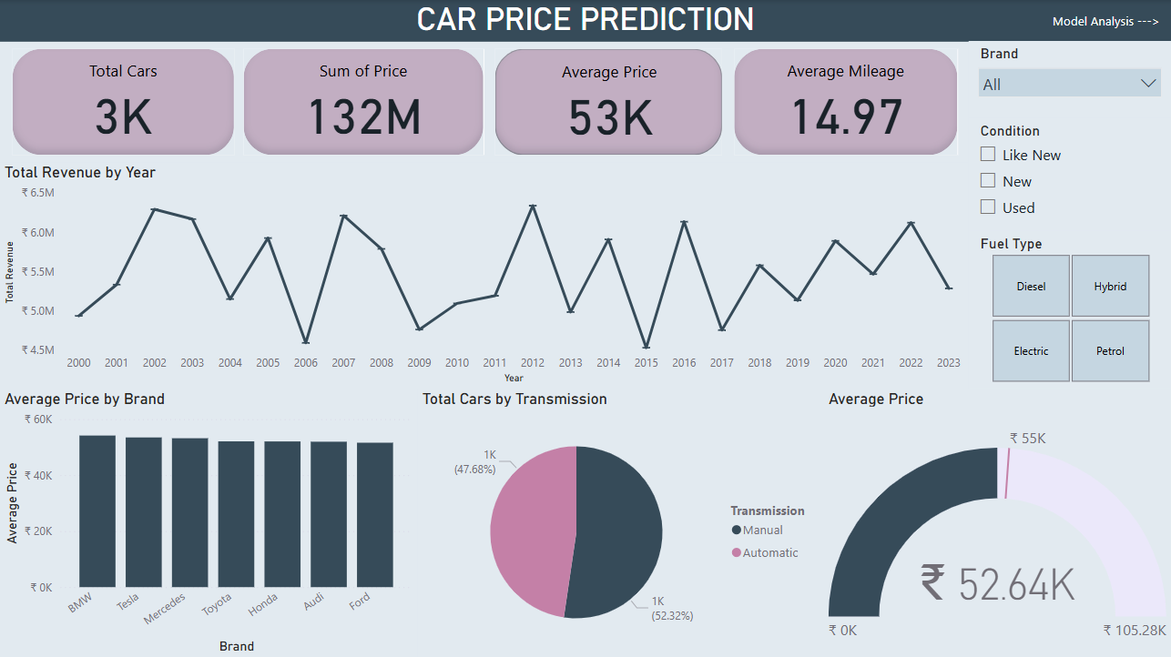

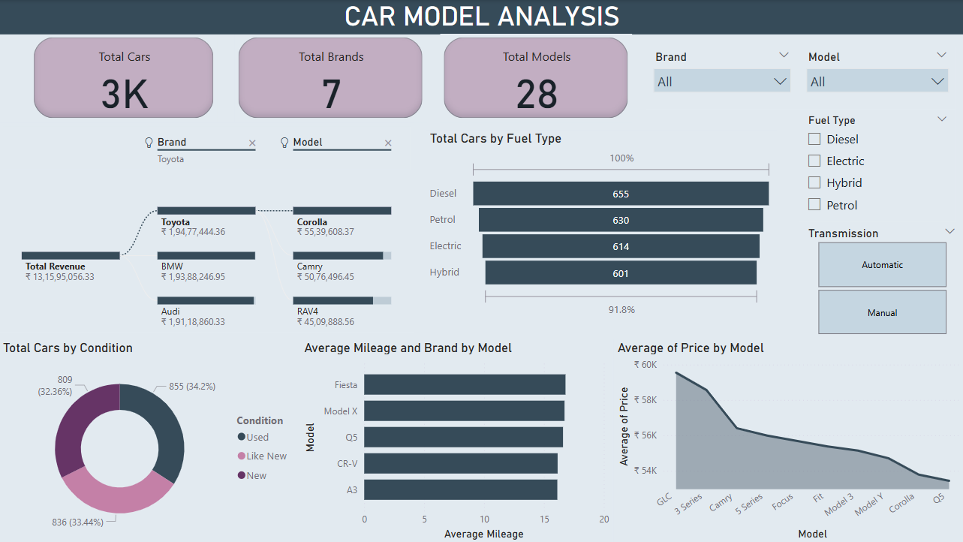

**INSIGHTS**

1. **Total Market Overview:**

* A total of 3K cars are analysed across 7 brands and 28 models.
* The total revenue generated from car sales is approximately ₹13.16 crore.
* The average car price is ₹53K, with total sales amounting to ₹132M.

1. **Brand and Model Performance:**

* Toyota, BMW, and Audi are the top brands in terms of revenue.
* Toyota's Corolla is the highest-selling model within Toyota, followed by Camry and RAV4.
* Luxury brands such as Mercedes, Tesla, and BMW maintain high average prices.

1. **Average Mileage by Model & Brand:**

* Models such as Fiesta, Model X, and Q5 offer the highest average mileage.
* Brands like Toyota, Honda, and Ford generally have models with better mileage.

1. **Transmission Preferences:**

* 52.32% of cars are Automatic
* 47.68% are Manual
* This indicates a slight preference for automatic transmissions.

**RECOMMENDATIONS**

1. **Target Luxury Car Buyers**

* Promote premium brands like Mercedes, Tesla, and BMW with financing options and premium service packages.

1. **Increase Inventory of Top Brands & Models**

* Stock more Toyota, BMW, and Audi models, especially the high-selling cars.

1. **Improve Marketing for Manual Cars**

* Since 47.68% of buyers still prefer manual cars, highlight their benefits (e.g., better control, lower maintenance costs).

1. **Enhance Customer Engagement & Sales**

* Offer discounts, trade-in deals, and financing plans to boost overall revenue and maintain market growth.

**CONCLUSION**

Car price prediction is a valuable application of data analytics, helping buyers and sellers make informed decisions. This project analysed key attributes like brand, model, year, mileage, and fuel type to estimate car prices accurately.

Data cleaning and transformation ensured accuracy, while DAX functions such as **CALCULATE, SUM, AVERAGE, IF, COUNTROWS, and TOPN** helped derive insights. These findings assist car dealerships and buyers in understanding market trends and pricing factors.

Future improvements, such as integrating machine learning, could enhance prediction accuracy, further demonstrating the power of **data-driven decision-making** in the automotive industry.